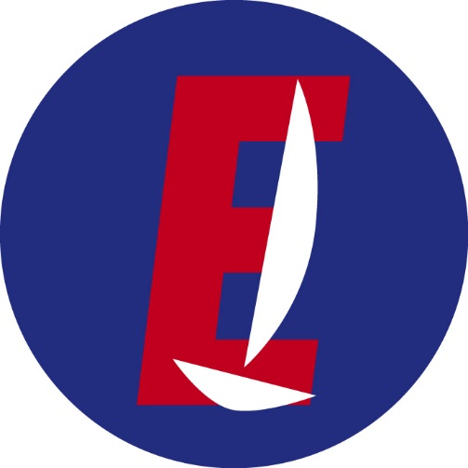

YOUTH EUROPEAN CHAMPIONSHIP 2021  
Club Nàutic El Masnou

**INTERNATIONAL EUROPE CLASS   
INSPECTION ENTRY FORM**

Please use the link below to enter your boat data and hit the 'Submit' button. You will get pdf file with your form by e-mail.

<https://forms.gle/zMF1h6ebzZPTj1Yw9>